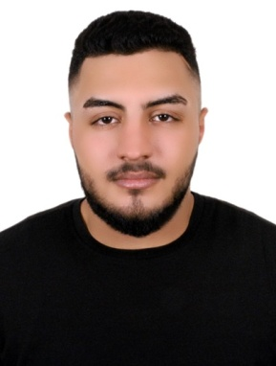**CURRICULAM VITAE**

ABDULLA SUFYAN SALEH AL FARSHISHI

Personal Profile

**Gender :** Male

**Nationality :** Bahraini

**Date of Birth :** 13-2-2000

Address : Flat 11 BLD 1296 Road 1814

AL LAWZI - 1018

**Mobile :** 39222503-33122946

**E-mail :** abdulla.sufyan2000@gmail.com

Education

|  |  |  |
| --- | --- | --- |
| 2015 - 2018 | Secondary SchoolCertificate  Specialization of Welding & Fabrication | Shaikh Abdullah Bin Isa AL  Khalifa  Technical Secondary School |
|  | Kitchen Standards Examination Certificate | Jasmi’s Corporation W.L.L. |

**Work Experience**

(06/08/2018 – Till now ) Jasmi’s Corporation W.L.L. as Service Crew & Barista

**Skills**

* Basic computer
* Friendly, helpful and polite
* Able to remain calm under pressure
* Quick and efficient
* Reliable and punctual
* Tactful and diplomatic
* Able to work effectively in a team
* Driving License

**Hobbies**

Swimming& Playing Taekwondo

## Language

Arabic (mother tongue), English (speak fluently)